AEPHY2021
Narrogin SHS Year 11 ATAR PHYSICS Name:
Task No: | 5
Task Type: | Test
Content: | Ionising radiation and nuclear reactions
Task Description: | Complete the attached questions in the spaces provided.  Marks will be awarded for presentation and working.  Test conditions (50 minutes).  Formulae and data booklet provided.  Non-programmable calculator permitted.
Total Marks: | 37
Weighting: | 6%
Materials required | pens, pencils (including coloured), sharpener, correction fluid, eraser, ruler, highlighters, scientific calculator
Due Date:

- How is mass number different to atomic number? Use an example to assist with your answer
(2 marks)

- Explain how differences between an alpha particle and a beta particle result in their different penetrating ability.
- marks)

- Americium -241 undergoes transmutation to Neptunium -237 as a result of radioactive decay.
- Write a nuclear equation showing the type of particle emitted.
(2 marks)

- Which property of the Am-241 nuclide makes it likely to undergo this type of decay? (1 mark)

- A film badge worn by a nuclear medicine technician indicated the following monthly exposure:

gamma radiation: 0.2 Sv
beta radiation: 0.4 Sv

- What is the technician’s absorbed dose for each radiation type?
(2 marks)

- If the technician’s body mass is 70 kg, how much energy did her body absorb from the radiation? (2 marks)

5. Calculate the binding energy of a Th-228 atom (including electrons)
in MeV

(mass of proton – 1.00728 u)
(mass of neutron – 1.00867 u)
(mass of electron – 0.000549 u)
(mass of Th-228 atom – 228.0287 u)
(4 marks)

- Calculate the energy released (in Joules) in the fusion reaction:
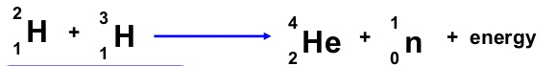

The masses are: H-2 = 3.344 x 10⁻²⁷ kg
H-3 = 5.007 x 10⁻²⁷ kg
He-4 = 6.645 x 10⁻²⁷ kg
Neutron = 1.675 x 10⁻²⁷ kg (4 marks)

- An original 100 g sample of uranium 232 decays to a mass of 6.25 g in 288 years. Calculate the half-life of U-232
(2 marks)

- Examine the following picture of a nuclear reactor. Label the following parts
  - shield
  - control rods
  - heat exchanger
  - fuel rods
  - moderator (5 marks)

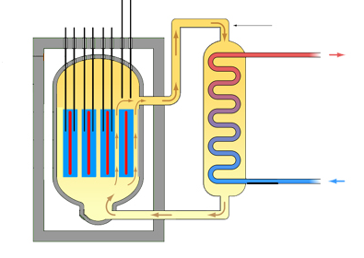

- A sample of plutonium has been recovered by a NATO inspector. What features will be used to determine whether the sample is weapons grade or fuel grade? (2 marks)

- Complete the following nuclear reactions.

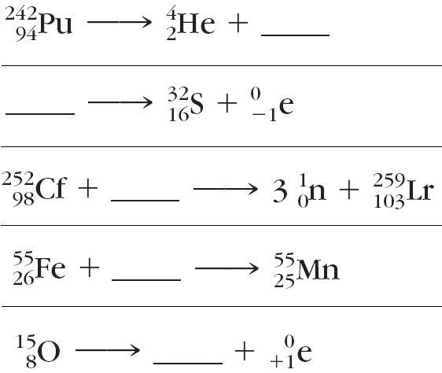
(5 marks)

End of Test

